Is there a trade-off between ephemeral feather growth and time in the nest in tree swallows? [need a better title]

Conor C. Taff1,2*, Brianna Johnson1, Allison Anker1, Alyssa Rodriguez1, Jenn Houtz1, Jenny Uehling1, Maren N. Vitousek1,2

1 Department of Ecology & Evolutionary Biology, Cornell University

2 Lab of Ornithology, Cornell University

* Correspondence: Conor C. Taff, [cct63@cornell.edu](mailto:cct63@cornell.edu) 518-332-3983

* Tom & David may still be added to this too. Need to check in with them.

Student help:

* 2018 crew: Raisa, Jeremy, Allison, Audrey, Brianna, Kwame, Callum, Emma
* 2019 crew: Kai, Alex, Alex, Alyssa, Christine, Zapporah, Bella, Yusol, Raquel, Paige, Bashir, Jabril
* Help with photos of feathers: Brittany
* Some feather measurements of adults? Bella, Raquel, Sungmin, Paige, Kai

**ABSTRACT**

***Keywords:***

**INTRODUCTION**

1. Intro paragraph
   1. Set up general idea of life history trade-offs, limited resources, etc
2. Ephemeral traits in general
   1. Build directly from the intro and justification of the Callan paper
3. Cross species vs. within species comparisons
   1. When do we expect trade-offs that appear in cross species comparisons (Callan paper) to hold within a single species? Are there reasons to think they should or shouldn’t hold for within species comparisons?
   2. Ecological fallacy/simpson’s paradox/jensen’s inequality,
   3. Look at Anurag Agrawal’s paper from last year on trade-offs across scales
4. Context dependence of trade-offs
   1. Could depend on underlying resources -> predators/energy treatments
   2. Predators change lots of things about nestling development (see Tom Martin papers)
   3. Van noordwijk & de jong resource allocation paper
5. Importance of feathers and molting in general
   1. Could go here or up in #2 depending on how this gets written
   2. Why are feathers important: thermoregulation, signaling, flight, etc
   3. But early feathers are molted quickly so potentially big investment for a short time
6. Tree swallow system
   1. Low predation so relatively relaxed time to develop?
   2. But sensitive to resource availability and allocating to different types of development?
   3. Feathers could be an unnecessary cost, but could also be important for thermoregulation
7. Specifics of this study and hypotheses/predictions
   1. Cross fostered nestlings monitored in two years
   2. Treatments on adults that altered development time/resources
   3. Remote system to monitor exact fledging age with multiple time point development measures
   4. Some predictions: read through Callan and think about how to rephrase their cross species hypothesis for within a species
      1. Trade-off more likely to occur in resource limited (predator) treatments

Across taxa, organisms employ a variety of life history strategies to maximize individual or population fitness. These strategies show tremendous diversity, as organisms phenotypically evolve to profoundly different environments while under varying intrinsic and extrinsic constraints. A key component of these varying strategies is life history trade-offs, wherein evolution attempts to optimize fitness through the success of one fitness component at the cost of another (Roff 1992, Sterns 2000). Classic examples of life history trade-offs look at relationships such as survival versus reproduction, quantity versus quality of offspring, and rate of development versus quality of development (Stearns 1992).

We focus on the lattermost of these life history trade-offs and seek to understand how the development of ephemeral traits ultimately impacts life history strategies. The rate and quality of ephemeral trait development requires varying levels of resource allocation. Given constraints on resources, life history theory predicts that rapid growth and development negatively impacts adult fitness and survival (Metcalfe and Monaghan 2003). Interestingly, this predicted trade-off between fast development and ultimate survival has been contradicted in an interspecific study across 90 songbird species (Martin 2015). This incongruence suggests an incomplete understanding of this resource allocation trade-off. One potential explanation for this observation centers around the idea that fitness costs of poor ephemeral trait quality are low. Therefore, the fitness costs of rapid development and poor ephemeral trait allocation may be ameliorated by subsequently higher chances of survival, especially in the face of environmental factors, such as predation (Callan 2019). However, the relationship/trade off discerned from this example occurs at an interspecific level.

There is reason to believe life history trade-offs may vary across levels of organization (Agrawal 2019). Specifically, interspecific trait associations may confound life history strategies that can be understood at the intraspecific level. Many broad theories in the life sciences support this understanding. Simpson’s paradox more broadly situates this concept in the context of probability by demonstrating how a trend observed within a specific group may be reversed when data from multiple groups is combined (Simpson 1951). Jensen’s inequality further describes the inability to rely on average conditions to accurately identify variance (Ruel 1999). Finally, the “ecological fallacy” posits that serious errors in analysis may occur as a result of using variables that describe groups of individuals, instead of the individuals themselves (Piantadosi 1988). The difference between ecological correlations and individual correlations should not be ignored (Robinson 1950). Therefore, the predicted life history trade-off between rate of development and adult fitness and survival may need to be situated in an intraspecific context to be fully understood.

We examined this life history trade-off within a population of tree swallows (*Tachycineta bicolor*), specifically focusing on feather quality. This ephemeral trait is salient for thermoregulation, signaling, and flight and may have important implications for energy and resource allocation within the individual. Thermoregulation alone can account for up to a third of all metabolized energy in altricial young (Weathers and Sullivan 1991). However, feathers developed in altricial young are quickly molted. Therefore, investment in nestling feather quality is quickly lost upon molting.

PARA: specifics of tree swallow system/predation

PARA: hypotheses/predictions

**METHODS**

*General Field Methods*

We studied tree swallows breeding near Ithaca, New York, USA in 2018 and 2019 (42.503° N, 76.437° W). During each breeding season (May to July), we monitored every nest at the field sites following established protocols for this long-studied tree swallow population (Winkler et al., 2020). Briefly, each nest box was checked every other day early in the season to determine clutch initiation and clutch completion date to within one day. Around the expected hatching day, we checked boxes every day so that an exact hatch date could be recorded.

Adults at each nest were captured during incubation or provisioning as part of an experiment focused on female responses to social and ecological challenges (Taff et al., In prep). For adults, we took morphological measurements (mass, flattened wing-chord length, and head + bill length), a blood sample for paternity, and 6-8 feathers each from the center of the white breast and the rump just above the tail to measure barb density (see below). For individuals that were not already banded from a previous year, we applied an aluminum USGS band and a passive integrated transponder (PIT) tag that encoded a unique 10-digit hexadecimal string.

Females at most nests in these two years were part of an experiment in which they received a social signal manipulation (dulling or sham coloring of the white breast) coupled with an ecological challenge (simulated predation attempts or a flight efficiency reduction). In 2018, the signal manipulation occurred first and was followed by the ecological challenge, while in 2019 the order was reversed. These treatments were focused entirely on the adult females at each nest, but they had indirect effects on nestlings resulting in lower overall fledging success at the predation treatment groups in each year (Taff et al., In prep). It is unclear what mechanism drove those differences, as females in each group provisioned nestlings at a similar rate, but presumably some difference in female behavior or reproductive investment translated into a harsher developmental environment for nestlings (Taff et al., In prep). In our analyses here, we accounted for female treatment by looking for overall differences in fledging time and feather quality among nestlings raised with social mothers in each treatment group and by asking whether any trade-off between feather quality and development differed between the treatment groups.

*Cross-Fostering and Nestling Measurements*

One of the goals of this study was to determine the degree to which environmental conditions versus genetic contributions drove differences in feather quality and nestling development. Therefore, we cross fostered eggs from each nest before incubation began so that any contribution to nestling feather development driven by developmental environment (e.g., incubation, provisioning rate) was decoupled from genetic inheritance or maternal effects associated with investment in the egg contents.

We paired nests based on timing of clutch initiation and on day 4 of egg laying we swapped half of the brood between the pair and marked all eggs in each nest with a pencil on the bottom of each egg. At half of the nests, we returned on the following day and swapped the 5th (unmarked) egg between the two nests. This two-step process ensured that some eggs from early and late in the laying order were swapped in case there were differences in yolk contents associated with laying order. In cases where there was not an appropriate nest to swap, we sometimes paired three nests together for cross fostering. A few late season nests did not have any compatible pairs and were not cross fostered.

We banded nestlings when they were 12 days old, collected a blood sample for paternity assignment, and took morphological measurements (mass, wing length, and head + bill length). When nestlings were 15 days old we once again took a mass measurement, applied a unique PIT tag, and collected feathers to measure barb density exactly as described above for adults. After day 15 we avoided visiting the nest to prevent forced fledging. Final nestling fate and exact fledging date were determined using RFID records and a check of the nest on day 24 to find any nestlings that had died in the nest after day 15.

*RFID Sensor Network*

We installed an RFID system at each nest box in the study on day 4 of incubation (as in Vitousek et al., 2018). The system consisted of an RFID board held in a waterproof container on the bottom of the nest box (Bridge & Bonter, 2011), an antenna that circled the nest box entrance, and a 12-volt battery that powered the system. We programmed the readers to record PIT tags within range of the entrance hole every second from 5am to 10pm each day of the breeding season. From raw RFID records, we extracted female and—when possible—male provisioning rates at each nest following the algorithm described in Vitousek et al. (2018). We also used RFID records to determine the exact age of fledging for each nestling in the population. For each individual nestling, we considered the latest record at the nest box to be the time of fledging. While it is possible that nestlings could leave and then return to the box, we saw no evidence for this behavior in our RFID data even when the sensors were left running long after we had confirmed fledging. Occasionally, RFID units failed because of software problems or dead batteries and we are therefore missing some records from periods of the provisioning period or fledging times for some nestlings.

*Feather Measurements*

We measured the density of feather barbs for adults and nestlings following the method developed by Butler et al. (2008) as described in Callan et al. (2019), except that we modified their approach for use with photographs rather than measuring with a dissecting scope. To take photographs, we spread each feather on a microscope slide that had been covered in contrasting cardstock paper with a scale bar. We used black paper as a background when photographing white breast feathers and white paper when photographing brown, green, and blue rump feathers. The feather was pressed down flat with a second clear microscope slide and photographed using a digital camera held in place on a document-scanning platform with diffuse lights. The camera mount ensured that photographs were in sharp focus and always taken at a direct 90° angle from the slide surface to avoid parallax issues when measuring. For each individual, we photographed two breast and two rump feathers.

From the digital photographs, we measured the density of feather barbs using ImageJ (Schneider et al., 2012). We first set the scale for each image using the scale bar that was included in every photograph. Next, we identified the section of the rachis to be measured and marked those points with the annotation tool in ImageJ. For the start point, we chose the most distal point on the feather rachis where a pennaceous barb could be seen branching off from the rachis. For the end point, we chose the most proximal point on the rachis where pennaceous barbs could be clearly seen branching off of the rachis before becoming plumulaceous.

We next measured and recorded the length of the rachis between these two points using the segmented line tool. Finally, we counted the number of pennaceous barbs between the two points and recorded the left and right side barbs separately. We calculated a single barb density measure for the feather by dividing the average count of barbs from the two sides by the length of feather rachis measured and expressed density in terms of barbs per centimeter of rachis. We repeated this procedure for the two breast and two rump feathers and then averaged the two replicate measurements from each region together to arrive at a single breast density and rump density measurement. We used multiple feathers from the same bird to estimate repeatability and multiple measurements of the same photo to estimate inter-observer measurement error (see supplementary methods). In some cases, we did not have complete measurements because we were missing feathers or had only a single feather. For some nestlings, feathers were so under-developed by day 15 that they were impossible to measure, and those nestlings are excluded from most analyses.

*Nestling Paternity and Molecular Sexing*

Adult and nestling blood samples were stored in lysis buffer (Seutin et al., 1991) in the field and DNA was extracted using Qiagen DNeasy Blood & Tissue Kit spin columns following the standard kit protocol in the lab. We amplified a set of 9 variable microsatellite loci that have been previously used in this population (Hallinger et al., 2019; Makarewich et al., 2009). Our amplification protocol exactly followed that described in Taff et al. (In prep) and details on primer sequences, reaction volumes, cycling conditions, and fragment analysis can be found there. We determined nest of origin by comparing nestlings to their putative mothers (the females from the 2-3 nests in each cross fostering pair). Nestlings that matched a female at 8 of 9 loci were considered to have been laid by that female. In total, x of x nestlings matched at 9 loci and x matched at 8 loci but the mismatch could be explained by a null allele. The other x nestlings could not be definitively assigned to a mother and are excluded from analyses that consider nest of origin (see Taff et al., In prep for discussion; note that this study uses a subset of nestlings from Taff et al. because not all nestlings had feather measurements).

*Data Analysis*

Fill in based on analyses done.

Repeatability of measurements was calculated using simple mixed models with no covariates in as implemented by the ‘rptR’ version 0.9.22 package in R (cite).

All figures and analyses were produced in R version 4.0.2 (R Core Development Team, 2020). All data and code required to reproduce the analyses presented here is available for review in a public GitHub repository (https://github.com/cct663/tres_feather_density).

**RESULTS**

In total, our analysis included 313 nestlings raised in 85 nests with at least one feather region measurement and 274 adults with at least one feather region measurement. In a validation dataset, inter-observer repeatability of barb density measurements from the same feather photograph was high (n = 149 measurements of 38 photographs by 8 observers; repeatability = 0.96; 95% CI = 0.94 to 0.98). Measurements of two independent feathers from the back or the breast of the same bird were also repeatable (breast: n = 1123 measures of 572 individuals; repeatability = 0.78; CI = 0.74 to 0.81; back: n = 1021 measures of 572 individuals; repeatability = 0.68; CI = 0.63 to 0.72).

Overall, there was a moderate positive correlation between barb density of back and breast feathers within an individual (Figure 1). This relationship was observed for both adults and nestlings with a similar slope in each group (Pearson’s correlation for adults and nestlings combined: *r* = 0.66, CI = 0.61 to 0.70; adults *r* = 0.34, CI = 0.23 to 0.45; nestlings *r* = 0.24, CI = 0.13 to 0.35).

As expected, adults had substantially higher barb density for both back and breast feathers (Figure 1). For back feathers, nestlings had an overall barb density of 17.9 barbs per cm, while adults had 24.3 barbs per cm (LMM with nest as a random effect, β for nestlings = -6.39, CI = -6.97 to -5.81). For breast feathers, nestlings had an overall barb density of 20.4 barbs per cm, while adults had 28.2 barbs per cm (LMM β for nestlings = -7.79, CI = -8.33 to -7.26). Thus, nestlings had on average 73.7 % (back) and 72.4 % (breast) of the barbs per cm as adults.

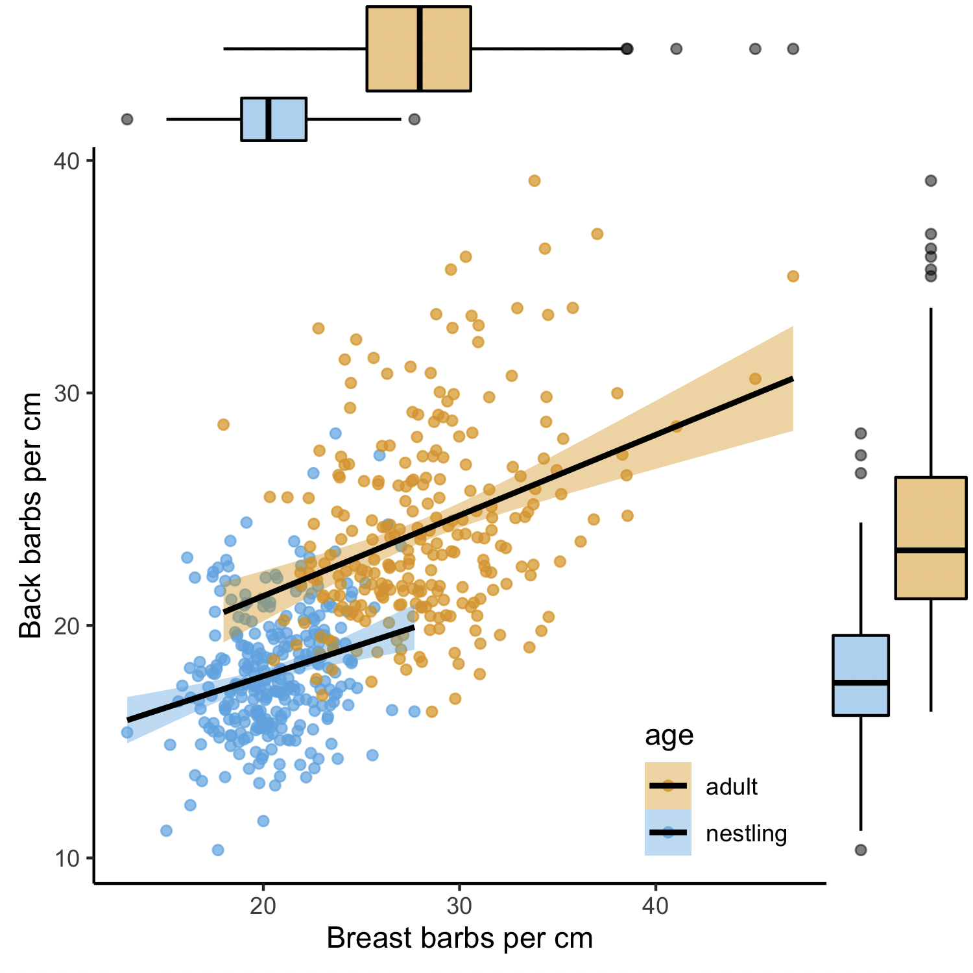

**Figure 1.** Relationship between breast and back barb density for feathers measured from the same individual for adults (orange) and nestlings (blue). Box and whisker plots in the margins show the distribution of barb density measurements for each body region and age group.

*Environmental and Genetic Influence on Barb Density*

For breast feathers, variation in nestling barb density was explained by both the genetic mother and the nest environment that a nestling was raised in. The adjusted intra-class correlation coefficient [ICC] of nest environment controlling for genetic mother in an LMM was 0.33 (CI = 0.2 to 0.442). The adjusted ICC of genetic mother controlling for nest environment in an LMM was 0.27 (CI = 0.14 to 0.39). For back feathers, genetic mother explained some variation in nestling barb density, but nest environment explained little. The adjusted ICC of genetic mother for back feather barb measurements controlling for nest environment was 0.20 (CI = 0.05 to 0.34). The adjusted ICC of nest environment controlling for genetic mother was 0.07 (CI = 0.0 to 0.19).

For breast measurements, unadjusted ICC estimates were nearly identical, but for back measurements, unadjusted estimates were higher for both categories, suggesting that nest environment and genetic mother explained much of the same variation. Unadjusted ICC for genetic mother on back barbs was 0.26 (CI = 0.12 to 0.39) and for nest environment was 0.22 (CI = 0.08 to 0.34).

*Barb Density by Time in the Nest*

Nestlings fledged 22.6 days after hatching (standard deviation = 1.5, range = 18 to 29 days). Despite this variation in developmental time, there was no apparent relationship between time spent as a nestling and the density of feather barbs for either back or breast feathers (Figure 2). There was also no indication that the (lack of) relationship differed by treatment group (Table 1). However, there was a main effect of the predator treatment with nestlings from the predation treatment fledging later than those from control or handicap nests. Nest identity explained much of the variation in fledging age, but genetic mother explained little additional variation (Table x; marginal R2 for reduced model = 0.095, conditional R2 including random effects = 0.657).

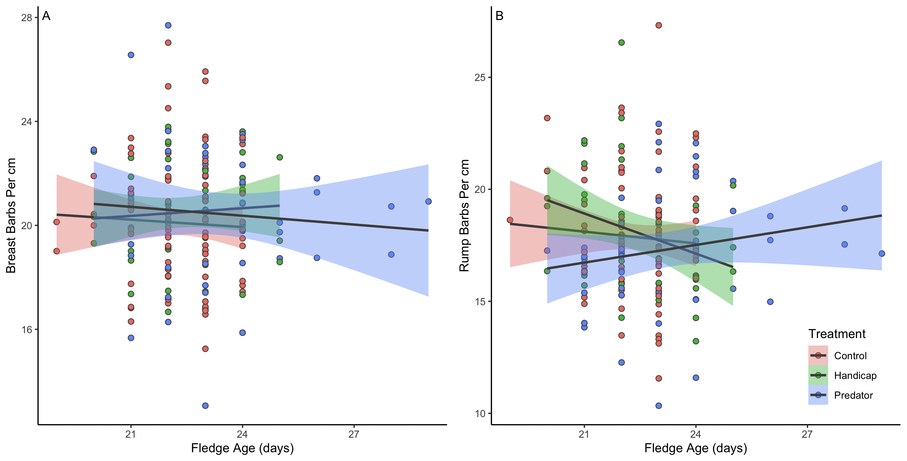

**Figure 2.** Fledging age in relation to breast (A) and back (B) barb density per cm for nestlings in the three different treatment groups. Marginal plots show the density distributions of fledging age and barb density for each treatment group.

**Table 1.** Feather barb density and nest treatment as predictors of fledging age.

*Barb Density in Relation to Nestling Morphology and Survival*

Breast feather barb density was positively related to day 12 and day 15 nestling mass, but only in the predator treatment group (Figure 3, Table 2). Back barb density was not related to nestling morphology in any treatment group. Overall, nestlings raised in the predator treatment group had shorter wings on day 12 and lower mass on day 12 and 15 than did nestlings raised in either the handicap or control group (Table 2). However, the amount of variation explained by feather measurements was small compared to that explained by random effects fitted for the nest environment and the genetic mother (Table 2; marginal R2 of main effects = 0.02 to 0.09; conditional R2 including random effects = 0.32 to 0.70).

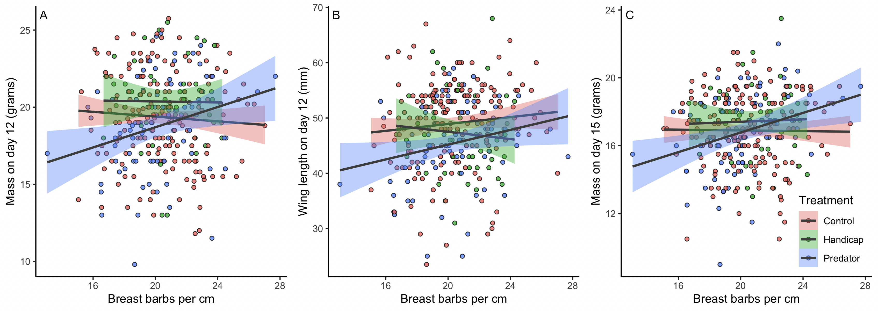

**Figure 3.** Nestling mass on day 12 (A), flattened wing cord length on day 12 (B), and mass on day 15 (C) in relation to breast feather barb density by treatment group.

**Table 2.** Linear mixed models showing relationship between barb density and nestling morphology by treatment group. Genetic mother and nest of development are included as random effects.

**DISCUSSION**

1. Summary of main results and their implication
2. Compare/contrast with Callan paper results
3. Is spending a longer time in the nest good because of slow/controlled development, or bad because of lower resources that force slow development? Or maybe quadratic?
4. Multiple stressors/challenges/climate change and ephemeral traits: maybe can get away with skimping on these traits in some situations, but if things are hard that might not work out (e.g., cold snaps – connect to Ryan’s new PNAS paper and their hand raised paper).
5. Caveats or things that aren’t clear from our paper

**ETHICAL NOTE**

We received approval for all of the procedures described here from the Cornell University Institutional Animal Care & Use Board (IACUC protocol # xxx). Sampling and capture in the field were approved by federal and state scientific collecting permits to MNV (federal permit # xxx; state permit # xxx).

**ACKNOWLEDGMENTS**

We thank the field and lab technicians who helped to collect data for this project, including Bashir Ali, Paige Becker, Raquel Castromante, KaiXin Chen, Jeremy Collison, Alex Dopkin, Zapporah Ellis, Audrey Fox, Sungmin Ko, Raisa Kochmaruk, Christine Kallenberg, Alex Lee-Papastavros, Jabril Mohammed, Yusol Park, Callum Poulin, Emma Regnier, Bella Somoza, and Kwame Tannis. [Brittany]

**AUTHOR CONTRIBUTIONS**

Maybe wait and see if the journal we submit to requires this or not.

**FUNDING**

Funding from CLO for students, DARPA + NSF. Others? Maren, can you fill in this section?

**REFERENCES**

Bridge, E. S., & Bonter, D. N. (2011). A low-cost radio frequency identification device for ornithological research. *Journal of Field Ornithology*, *82*(1), 52–59. https://doi.org/10.1111/j.1557-9263.2010.00307.x

Butler, L. K., Rohwer, S., & Speidel, M. G. (2008). Quantifying structural variation in contour feathers to address functional variation and life history trade-offs. *Journal of Avian Biology*, *39*(6), 629–639. https://doi.org/10.1111/j.1600-048X.2008.04432.x

Callan, L. M., La Sorte, F. A., Martin, T. E., & Rohwer, V. G. (2019). Higher Nest Predation Favors Rapid Fledging at the Cost of Plumage Quality in Nestling Birds. *The American Naturalist*, 000–000. https://doi.org/10.1086/702856

Griffiths, R., Daan, S., & Dijkstra, C. (1996). Sex identification in birds using two CHD genes. *Proceedings of the Royal Society of London, Series B*, *263*, 1251–1256.

Hallinger, K. K., Vitousek, M. N., & Winkler, D. W. (2019). Differences in perceived predation risk associated with variation in relative size of extra-pair and within-pair offspring. *J Evol Biol*. https://doi.org/10.1111/jeb.13564

Makarewich, C. A., Stenzler, L. M., Ferretti, V., Winkler, D. W., & Lovette, I. J. (2009). Isolation and characterization of microsatellite markers from three species of swallows in the genus *Tachycineta: T. albilinea, T. bicolor* and *T. leucorrhoa*. *Molecular Ecology Resources*, *9*(2), 631–635. https://doi.org/10.1111/j.1755-0998.2008.02484.x

R Core Development Team. (2020). *R: A language and environment for statistical computing, Vienna, Austria.* R Foundation for Statistical Computing. https://www.R-project.org/

Schneider, C. A., Rasband, W. S., & Eliceiri, K. W. (2012). NIH Image to ImageJ: 25 years of image analysis. *Nature Methods*, *9*(7), 671–675. https://doi.org/10.1038/nmeth.2089

Seutin, G., White, B. N., & Boag, P. T. (1991). Preservation of avian blood and tissue samples for DNA analyses. *Canadian Journal of Zoology*, *69*(1), 82–90.

Taff, C. C., Zimmer, C., Uehling, J., Ryan, T., Oordt, D. C. van, Houtz, J., Injaian, A., & Vitousek, M. N. (In prep). Social signal and ecological challenge manipulation experiment in tree swallows. *In Prep*.

Vitousek, M. N., Taff, C. C., Stedman, J., Zimmer, C., Ardia, D. R., Salzman, T. C., & Winkler, D. W. (2018). The lingering impact of stress: brief acute glucocorticoid exposure has sustained, dose-dependent effects on reproduction. *Proc Roy Soc B*, *285*, 20180722.

Whittingham, L. A., & Dunn, P. O. (2000). Offspring sex ratios in tree swallows: females in better condition produce more sons. *Mol Ecol*, *9*(8), 1123–1129.

Winkler, D. W., Hallinger, K. K., Pegan, T. M., Taff, C. C., Verhoeven, M. A., Oordt, D. C. van, Stager, M., Uehling, J. J., Vitousek, M. N., Andersen, M. J., Ardia, D. R., Belmaker, A., Ferretti, V., Forsman, A. M., Gaul, J. R., Llambias, P. E., Orzechowski, S. C., Shipley, J. R., Wilson, M., & Yoon, H. S. (2020). Full lifetime perspectives on the costs and benefits of lay-date variation in tree swallows. *Ecology*, *101*(9), e03109. https://doi.org/10.1002/ecy.3109